Test evidences

Test 1:
Table: FROM DAILY_RETURN_AUDIT
Entity: DailyReturnAudit
Repository: DailyReturnAuditRepository
Created
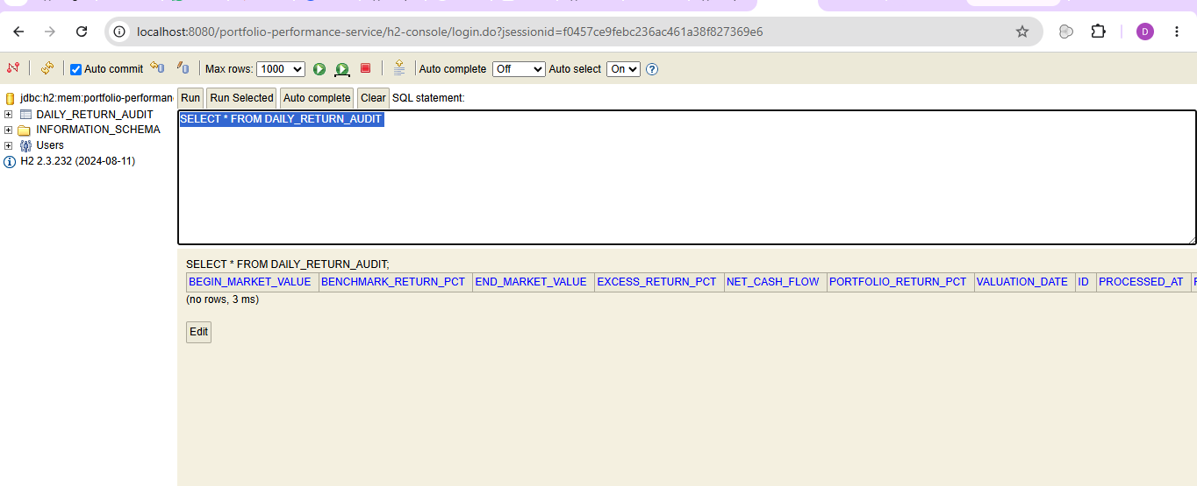

Test 2:
Request and Response model created
